|  |
| --- |
| **JDN Standards –** **EX firmware upgrade FTP** |

Setup FTP 1

Upgrade Firmware 3

# Setup FTP

Log in to synology cluster and create new share.

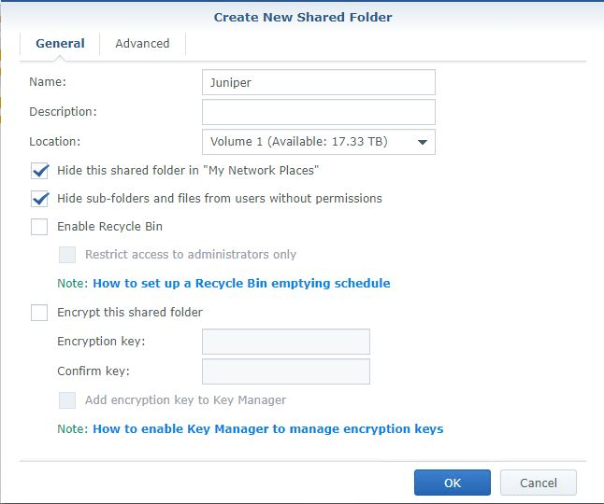

Set Read only access on the ‘anonymous FTP’ user under ‘system internal users’.

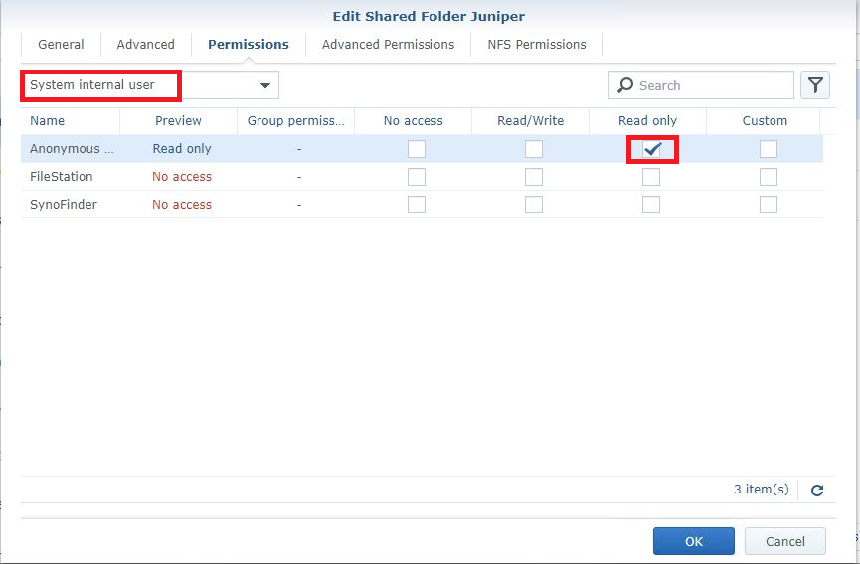

Enable FTP (possible that it is already enabled)

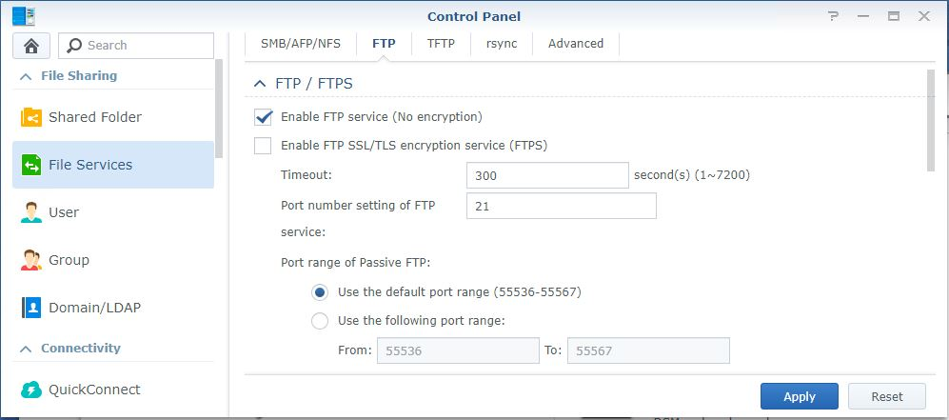

Modify advanced FTP settings

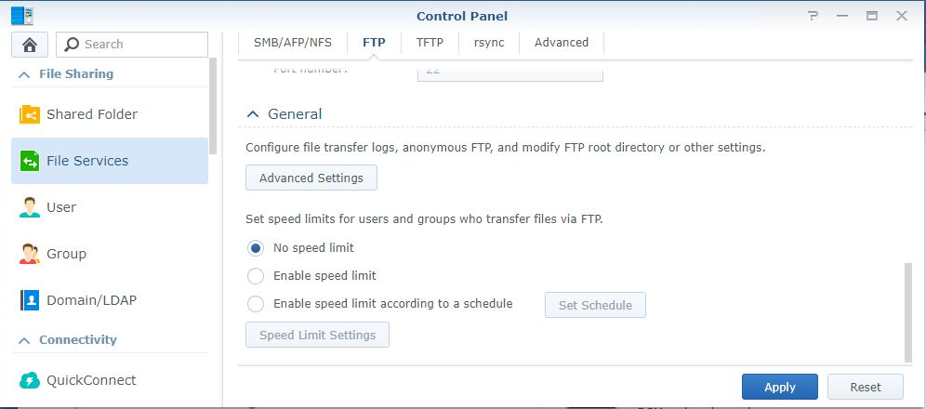

Enable Anonymous FTP and change the root folder.

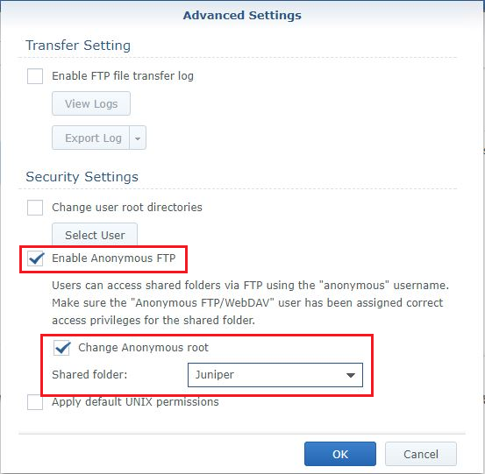

Copy Juniper Firmware’s in the Shared folder.

# Upgrade Firmware

Upgrade full stack or a single member to newer firmware by selecting the sinology FTP location instead of local file structure:

request system software add ftp://hostname/package.tgz reboot

Be aware that the device will reboot after the update, meaning loss of connection for the connected devices.

Request system snapshot slice alternate all-members

See the URL below for further info

<https://www.juniper.net/documentation/en_US/junos/topics/task/installation/ex-series-software-installing-single-routing-engine-cli.html>